🟢 Bandit Level 8 → Level 9
The password is in data.txt and is the only line that occurs exactly once.
Step 1: Check the file
ls
You should see:
data.txt
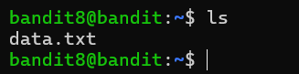
Step 2: Find the unique line
Use:
sort data.txt | uniq -u
🔑 Why?
- sort data.txt → arranges all lines together
- uniq -u → shows only the line that appears once
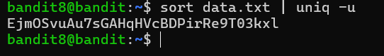
The output is the password for bandit9.
Then exit from that level

